**CHAPTER 4**

**How can citizens and the government work together for the good of society?**

|  |
| --- |
| **ADDRESSING THE NEEDS OF SOCIETY** |

* **Individuals** can positively impact society by volunteering in areas they're passionate about, using their skills and knowledge to help others. For instance, one could entertain or teach skills to the elderly in nursing homes.
* A blue and yellow text

  Description automatically generatedCitizens can also form or **join community groups** like RSVP, a social service agency, where they can engage in volunteerism, especially beneficial for senior citizens.
* 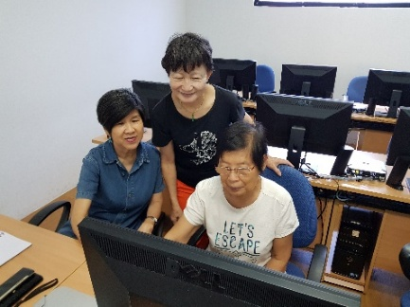Such community groups can utilize their collective skills, experiences, and government-provided resources to address societal needs, like caring for the disabled, sick, or elderly.
* **Government agencies** collaborate with these community groups to enhance their capacities. An example is the National Council of Social Service (NCSS) developing tools like the Volunteer Management Toolkit 2.0, which provides a framework for effective volunteer management for the community groups.
* 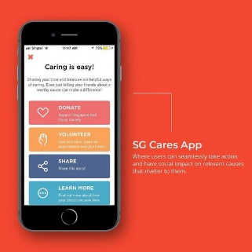**The government** sets up structures, policies and national programmes in a targeted manner, creating opportunities for the community to show care to those around them.
  + E.g., the mobile app – SGCare connects volunteers with volunteering opportunities and charity organisations so that citizens can contribute to those who need support.
  + This app can be used by individuals and community groups to address the needs of those who need it.
* **The combined efforts of individuals, communities, and the government result in an efficient, unified approach towards addressing the needs of society, enhancing overall societal welfare, and creating a stronger, more resilient community.**

|  |
| --- |
| **INFLUENCING DECISION MAKING IN PUBLIC AFFAIRS** |

* Solving societal problems requires sound decisions, which can be made by the collaborative efforts of citizens and the government through platforms such as REACH and the Citizen’s Jury.
* REACH, under the Ministry of Communications and Information, involves citizens in decision-making by gathering their views on public policies through engagement sessions and social media, and sharing these insights with relevant government agencies.
* An example of such collaboration is the Citizen’s Jury for the War on Diabetes, where the **MOH**, after launching a nationwide diabetes prevention and management initiative, **organized a citizen jury** to develop community-based solutions.
* 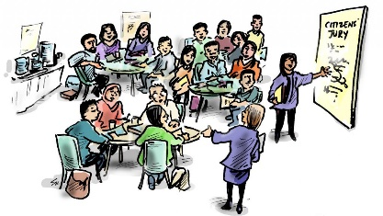Over seven weeks, the selected citizen jury discussed diabetes management challenges and solutions, resulting in MOH implementing several of their recommendations, including a campaign to promote water drinking.
* **This collaboration demonstrates that citizens can actively work with the government in influencing decision making, with the government ensuring equal and fair participation.**
* **The partnership between citizens and the government in decision-making brings a positive impact by generating effective solutions which addresses the needs of the people hence building a stronger and more resilient community.**

|  |
| --- |
| **STRENGTHENING SENSE OF BELONGING** |

* Strengthening citizens' sense of belonging can be achieved through unity and collaborative actions between citizens and the government.
* Common experiences such as celebrating national day or participating in programmes like 'Remaking our Heartland' and HDB’s 'Build a Playground' can create this unity, where citizens contribute to the design of neighbourhood spaces.
* An example of collaborative efforts in preserving heritage is the Dakota Crescent case. The government, in response to relocation plans, preserved some buildings for community use.
* 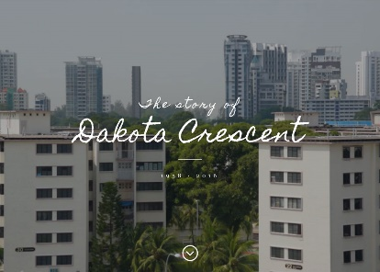Informal community group 'Between Two Homes' played an active role here, documenting heritage and discussing redevelopment plans through workshops and a multimedia website.
* The government provided support through 'Our Singapore Fund' which funded such projects, with 'Between Two Homes' being one of the beneficiaries.
* Individual volunteers from 'Between Two Homes' interviewed residents, becoming aware of their needs and aiding relocation efforts, developing community engagement.
* **Such joint efforts by individuals, community groups, and government can enhance citizens' sense of belonging by connecting them to the country's history, people, and places.**
* **This collaboration leads to increased care and proactive actions from citizens towards fellow Singaporeans, and greater concern about shaping the country’s future, ultimately creating a more unified and resilient society.**